DIGITAL TOOLKIT:
Supporting Principals’ Learning: Key Features of Effective Programs

Tweets

For Image 1 (infographic)
Does investing in #principals pay? Yes! In increased teacher effectiveness & student achievement. Via @LPI_Learning https://learningpolicyinstitute.org/product/supporting-principals-learning-key-features-effective-programs-report

Investing in quality leadership preparation can support increased student achievement. Research via @LPI_Learning https://learningpolicyinstitute.org/product/supporting-principals-learning-key-features-effective-programs-report

For Image 2 (infographic)
What do effective school leaders do? New research via @LPI_Learning #principals #leadershipmatters https://learningpolicyinstitute.org/product/supporting-principals-learning-key-features-effective-programs-report

What do effective principals do and how can districts support them? Research from @LPI_Learning https://learningpolicyinstitute.org/product/supporting-principals-learning-key-features-effective-programs-report

For Image 3 (infographic)
Policymakers can promote excellent schools by investing in #principals. Via @LPI_Learning https://learningpolicyinstitute.org/product/supporting-principals-learning-key-features-effective-programs-report

For Image 4 (data chart)
21% of teachers cite school leadership as a reason for leaving their jobs. Via @LPI_Learning #leadershipmatters https://learningpolicyinstitute.org/product/role-principals-addressing-teacher-shortages-brief

Did you know principals play a critical role in addressing the #teachershortage? This @LPI_Learning chart explains how. #principals: https://learningpolicyinstitute.org/product/role-principals-addressing-teacher-shortages-brief

For Image 5 (photo)
@LPI_Learning research shows how states can invest in high-quality principal development through #ESSA funds. https://learningpolicyinstitute.org/product/investing-effective-school-leadership-brief

--more--

Facebook Posts

Image 1
Could your school board, school district, or community-based organization use info on leadership development? Check out this @LearningPolicyInstitute report, fact sheet, and infographics. https://learningpolicyinstitute.org/product/supporting-principals-learning-key-features-effective-programs-report

Image 2
Principals play a critical role in addressing widespread teacher shortages by creating school environments that attract and retain competent teachers. The most effective principals assume a range of responsibilities, including setting direction, developing people, redesigning the organization, and leading and supporting instruction. Read more in this @LearningPolicyInstitute report. https://learningpolicyinstitute.org/product/supporting-principals-learning-key-features-effective-programs-report

Image 3
Improving student achievement requires strong school leadership. How can your district develop strong principals? This @LearningPolicyInstitute report shares evidence-based approaches. https://learningpolicyinstitute.org/product/supporting-principals-learning-key-features-effective-programs-report

Image 5
How can states foster powerful school leadership through their Every Student Succeeds Act plans? This @LearningPolicyInstitute research shows some research-based approaches that work. https://learningpolicyinstitute.org/product/investing-effective-school-leadership-brief

--more--

Sharable Social Media Images

Image 1
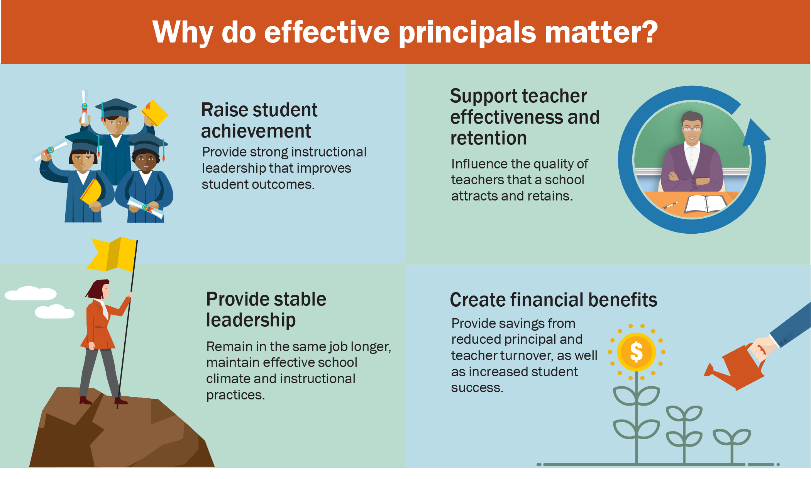

Image 2

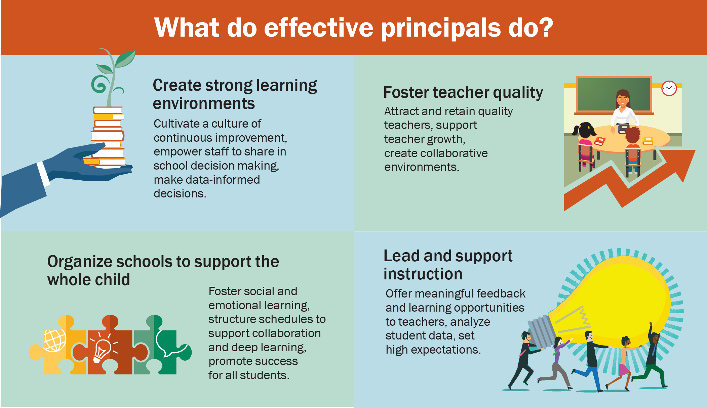

Image 3
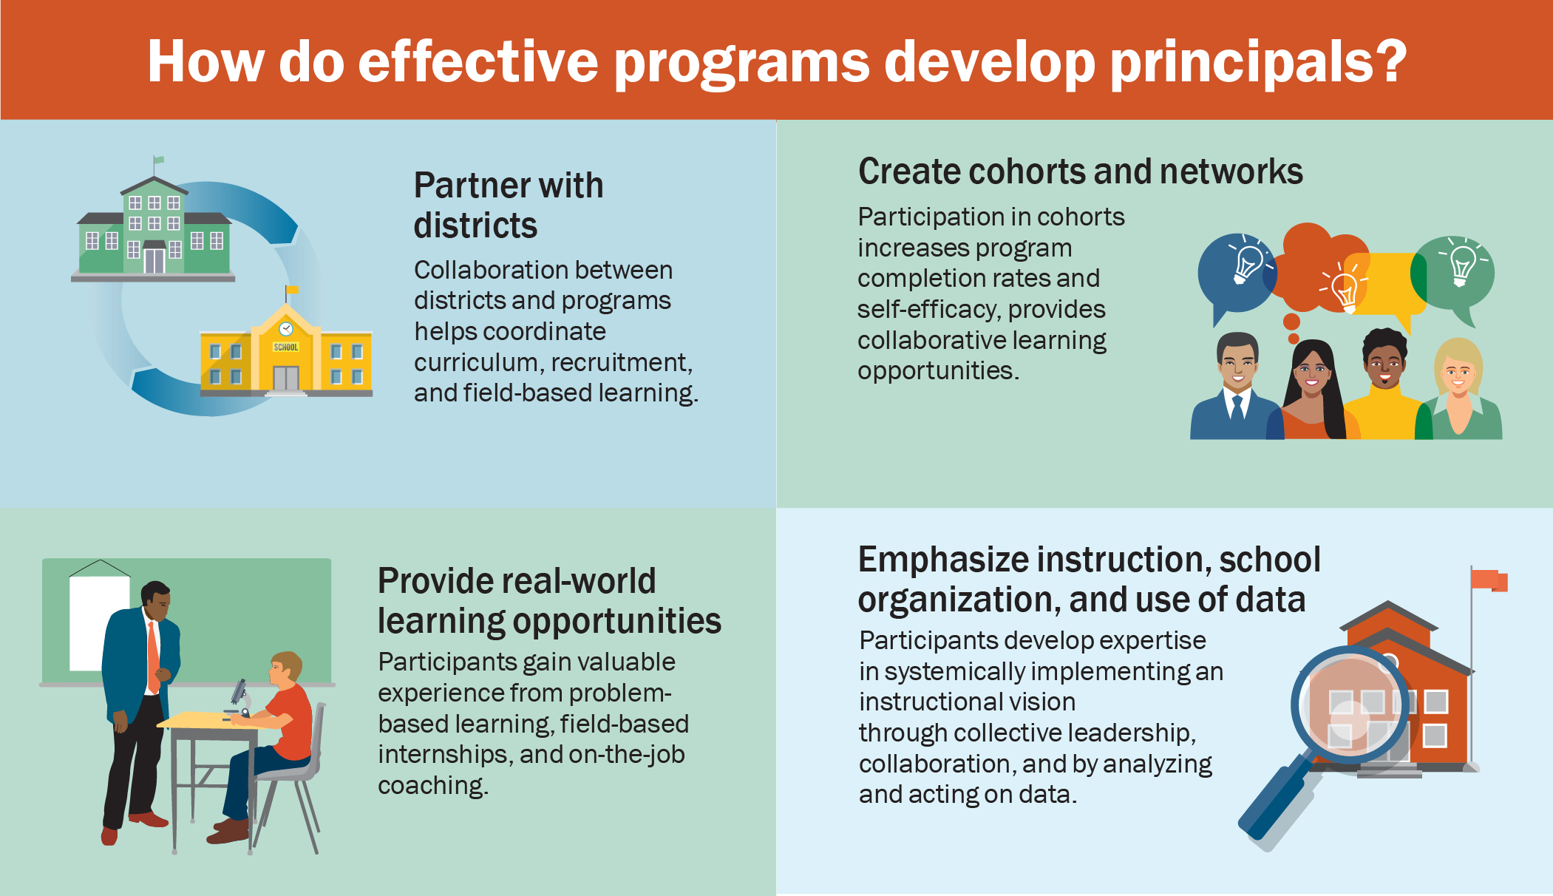

Image 4
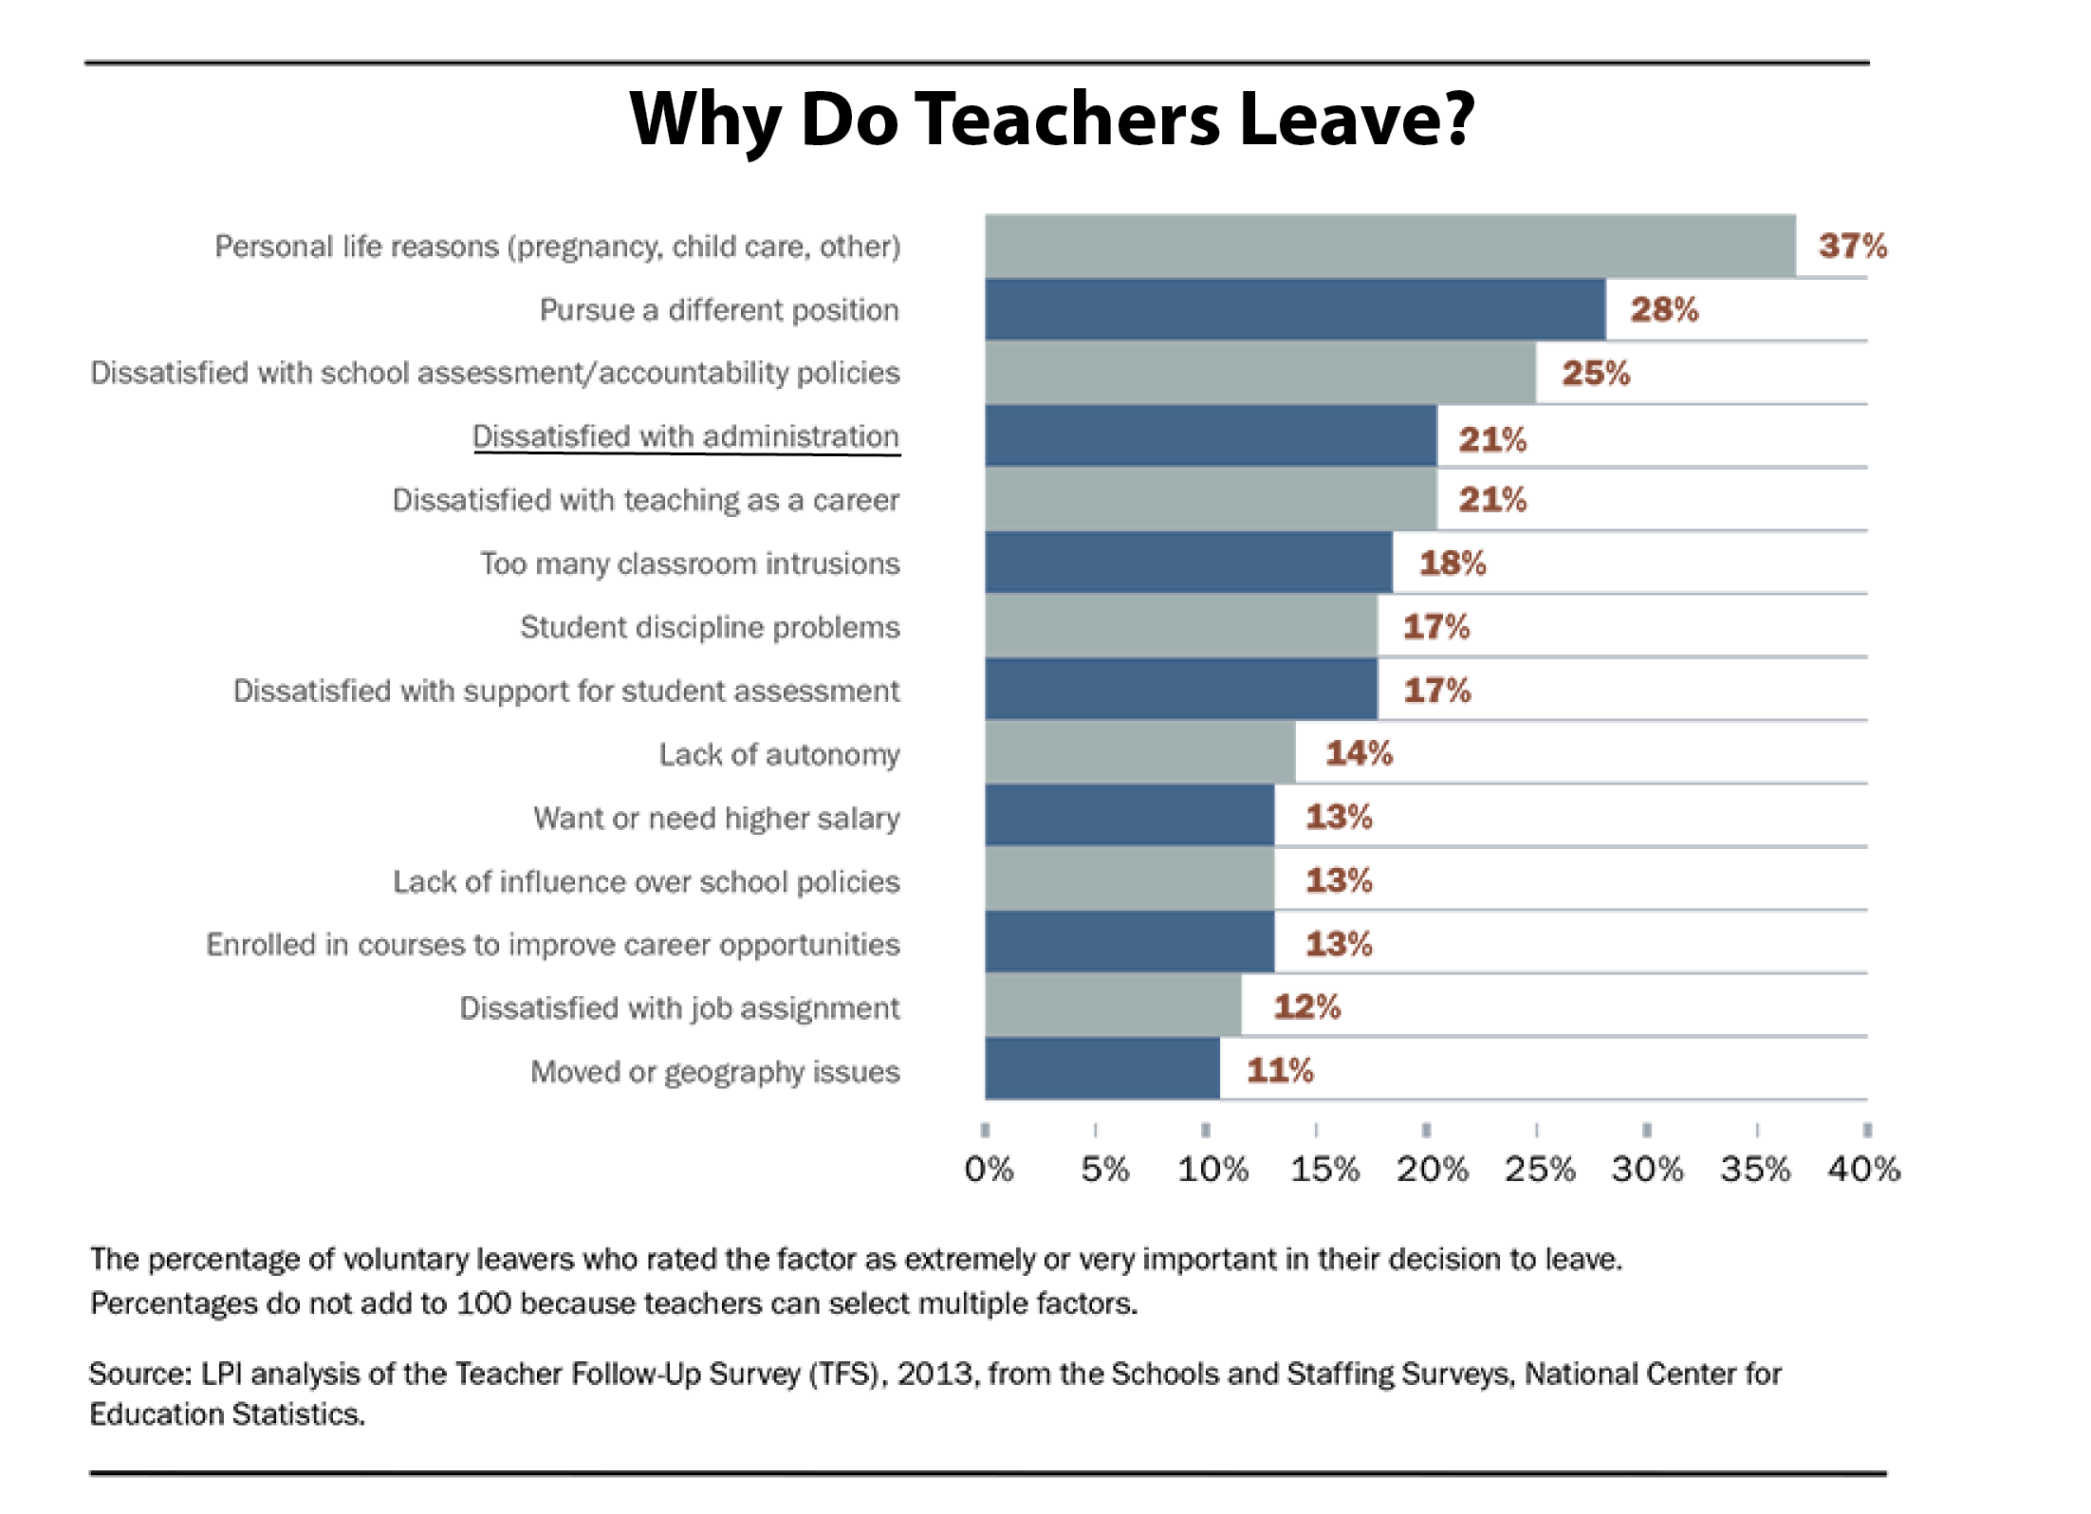

Image 5
